DLD

Experiment Report



FOURIER SYNTHESIS OF PERIODIC SIGNALS

Submitted by:

Amal Tariq | [23l6026]

Submitted to:
Sir Muiz Malik

[DATE]

Department of Electrical Engineering
National University of Computer and Emerging Sciences, Lahore

Introduction
- Problem Analysis

Design Requirements
- Feasibility Analysis

Possible Solutions
- Preliminary Design

Design Description

Software Simulation

Experimental Results
- Performance Analysis
- Future Scope

Social and Cultural Implications
- Conclusion References
The main idea of this project is to reconstruct periodic signals using Fourier synthesis by summing a finite number of sine wave components based on given Fourier coefficients. This demonstrates how complex waveforms can be built from simpler harmonic functions. Key concepts involved include Fourier series, trigonometric coefficients, harmonics, and the use of MATLAB for visualization. These concepts are significant because they form the foundation for signal analysis in engineering, enabling applications in audio processing, communications, and systems modeling. The project also explores the Gibbs phenomenon, which highlights the limitations of Fourier series near discontinuities. Additionally, the use of custom MATLAB functions introduces efficient coding practices, which enhance the clarity and reusability of the implementation.

The problem given in this project involves synthesizing periodic signals using their Fourier series representations. Specifically, it provides trigonometric Fourier coefficients for different signals and asks us to reconstruct the original signals by summing a finite number of harmonic sine terms. The task includes writing MATLAB functions to compute and visualize these approximations for various values of NN, the number of harmonics. To solve this, we first identify the type of Fourier coefficients (sine-only, cosine-only, or both), then use these to write the mathematical expression for the signal x(t)x(t). We implement this expression in MATLAB, allowing the number of terms NN to vary in order to observe how the approximation improves. By plotting the results for different values of NN, we can also analyze the effects of increasing harmonics and observe phenomena like the Gibbs phenomenon near signal discontinuities.

The design requirements of this project revolve around accurately synthesizing periodic signals using a finite number of Fourier series terms. The input to the problem includes the Fourier coefficients (ao, an, bn), the fundamental frequency ω0, the time range over which the signal is to be synthesized, and the number of harmonics NN to be used in the summation. The output is the reconstructed signal x(t)x(t) plotted over the specified time range, showing how closely the partial Fourier sum approximates the original signal. A key constraint is that only a finite number of harmonics can be used, meaning the approximation will never be perfect—especially near discontinuities, where the Gibbs phenomenon may occur. The system must therefore be designed to dynamically handle different values of NN, allow for real-time visualization in MATLAB, and maintain computational efficiency even with high-resolution time vectors.

. The feasibility of this project is strong in terms of both time management and cost management. From a time, management perspective, the project is well-structured and manageable within the typical duration of a lab cycle. The tasks—understanding the problem, writing MATLAB code, generating plots, and analyzing results—are clearly defined and can be completed in phases. Since the code can be reused with different parameters, significant time is saved during testing and visualization. From a cost management standpoint, the project requires minimal physical resources. The primary tools used are a computer and MATLAB software, both of which are typically available in academic labs or through student licenses. No additional equipment or materials are required, making the cost virtually zero. The only resource that needs careful management is computational time, especially when dealing with very small time steps or a high number of harmonics, which can increase processing load. However, with efficient coding practices and function-based modular design, these constraints are easily addressed. Overall, the project is highly feasible and well-suited to the lab environment.

For the problem of reconstructing periodic signals using Fourier series, there are multiple approaches available depending on how the implementation is structured. One common method is the script-based approach, where the Fourier series is computed and plotted by writing separate blocks of code for each set of parameters or harmonic values. While this method works for simple cases, it can become inefficient and repetitive when dealing with multiple scenarios. It lacks scalability, and changing parameters like the number of harmonics requires manual modification of the code in multiple places. This increases the chances of errors and makes the code harder to maintain.
The preferred and more efficient solution is the function-based approach, which involves designing reusable MATLAB functions. In this method, important parameters such as the number of harmonics, time range, and signal type are passed as arguments to the function. This makes the code modular, easier to read, and highly reusable. It allows for quick experimentation with different inputs without duplicating code. Additionally, this approach promotes cleaner organization and simplifies debugging and future enhancements.
Comparing both methods, the function-based approach clearly stands out as the better solution. It supports reusability, scalability, and efficient handling of computational tasks. It saves time and effort in the long run, especially when analyzing multiple signals or harmonic levels. Therefore, the function-based method is the most suitable and effective choice for solving the Fourier synthesis problem in this project.

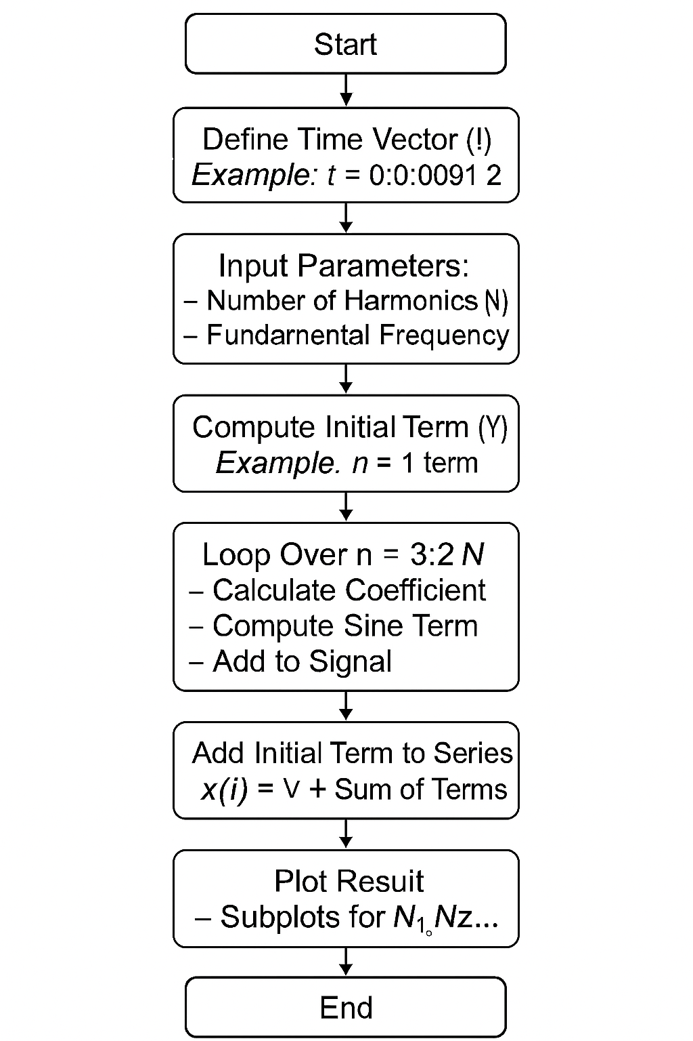

Problem 10.1:
a periodic signal using its Fourier sine series representation. The coefficients provided indicate that the signal is an odd function with only sine terms contributing to the series. The constant term adds a vertical shift, while all a terms are zero, and the bn terms are nonzero for odd nn. The function implemented to solve this is named plotFourierApprox (n1, n2, n3, n4), which accepts four different values of NN, the number of harmonics to include in the approximation. Inside the function, a high-resolution time vector t=0:0.0001:2t = 0:0.0001:2 is defined to capture signal variations smoothly. The initial base term YY is computed using the first harmonic, and then a loop iteratively adds odd harmonic terms up to the specified value of NN, using the given coefficients. Each resulting approximation is plotted using MATLAB subplots, making it easy to observe the improvement in accuracy as more harmonics are added.
The input parameters for this problem include the range of time, the number of harmonics NN, and the fundamental frequency ω0=2π\omega_0 = 2\pi. The MATLAB function efficiently synthesizes and plots the signal using these inputs. The results clearly demonstrate the Gibbs phenomenon, which refers to the overshoot that occurs near discontinuities when approximating a signal using a finite number of Fourier terms. Even as the number of terms increases, the overshoot does not disappear — it only becomes narrower and more concentrated near the jump points. This highlights a known limitation of Fourier series in representing non-smooth functions. As NN increases, the approximation becomes more accurate, closely following the original waveform and producing sharper transitions, but the Gibbs phenomenon remains evident near discontinuities. The function-based approach not only simplifies the process of generating multiple approximations but also makes the code reusable and easy to maintain.

Problem 10.2
In this problem, we work with a different Fourier sine series, where the bn coefficients are proportional to the expression given. This introduces a pattern where only selected odd harmonics contribute significantly to the signal. This form is typically used to represent piecewise functions such as a half-wave or square-like waveform. The function created for this task is called plotFourierSeriesB(n1, n2, n3, n4), which also accepts four values of NN to demonstrate the effect of increasing the number of terms in the approximation. The time vector for this problem ranges from −2-2 to 22, providing a symmetric view of the periodic signal. The first term is computed for n=1n = 1, and then additional harmonics are added in a loop for odd values of nn, following the provided coefficient formula. The function generates four subplots for comparison, each showing the synthesized signal for different harmonic limits.
The unknowns identified for solving this problem include the harmonic limit NN, the time range, and the fundamental frequency ω0=π\omega_0 = \pi. As in the previous case, increasing NN improves the quality of the approximation. The plots show a clearer signal shape with better-defined transitions as more harmonics are added. Again, the Gibbs phenomenon is visible near discontinuities, especially where the signal sharply changes direction. The overshoot remains present even with higher values of NN, though it becomes more localized. This effect illustrates the theoretical limitation of finite Fourier series and reinforces the importance of understanding convergence behavior in signal synthesis. Overall, this function offers an efficient, reusable, and visually clear way to study the impact of harmonic components in Fourier series representations.

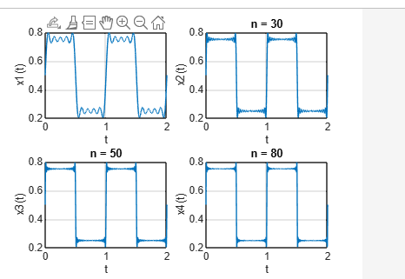

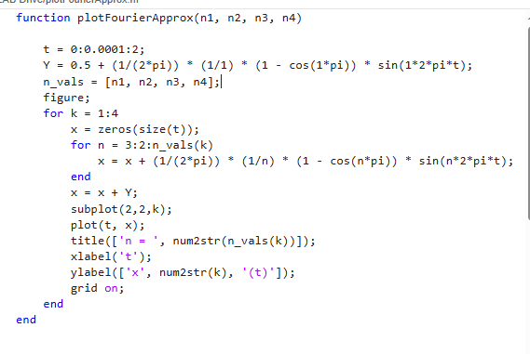

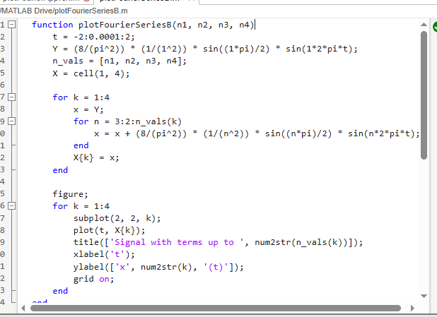

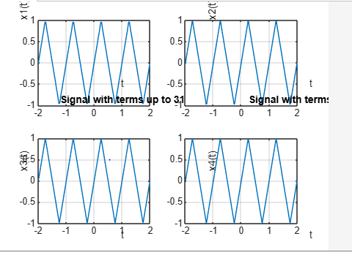

Analysis of the Results and Performance of the Solution
The results obtained from both functions, plotFourierApprox and plotFourierSeriesB, clearly demonstrate the effectiveness of Fourier series in approximating periodic signals. As seen in the generated plots, the accuracy of the reconstructed signal improves significantly with an increase in the number of harmonics NN. For small values of NN, the waveform is rough and only provides a general shape of the original signal. However, as NN increases, the signal becomes smoother and aligns more closely with the expected waveform. This confirms the theoretical understanding that the Fourier series converges to the original function as more terms are included.
A consistent pattern observed across both problems is the presence of Gibbs phenomenon—an overshoot near points of discontinuity in the waveform. Despite increasing the number of harmonics, the height of the overshoot remains nearly constant, although the overshoot becomes narrower and more localized. This illustrates a fundamental limitation of using a finite number of sine terms to represent functions with sharp transitions or jumps. Nevertheless, the visual fidelity of the signal away from the discontinuities becomes remarkably accurate with higher NN, showing that the Fourier series effectively captures the signal’s core features.
From a performance standpoint, the solution performs efficiently in MATLAB. The use of vectorized operations and function-based modular code design allowed for reusability and fast computations. Even with fine time steps and a large number of harmonics, the function was able to generate accurate plots without excessive processing time. Additionally, organizing the code into functions rather than repetitive scripts allowed for cleaner implementation, easier testing, and more scalable use in future experiments.
Overall, the performance of the solution meets the design requirements of the lab. It successfully synthesizes complex signals from their Fourier series, demonstrates convergence properties, and visualizes phenomena like Gibbs effect. The solution also adheres to good programming practices, making it not only academically sound but also practically efficient. This project validates both the theoretical foundation of Fourier analysis and its practical application using computational tools like MATLAB.

[Note: Discuss future scope of your design. Suggest possible improvements for your design. Remove this content while writing your report.]

In conclusion, the developed solution effectively demonstrates the concept and application of Fourier series in reconstructing periodic signals using MATLAB. Through the use of modular functions, we were able to synthesize two different signals based on given Fourier coefficients and observe their approximations at varying harmonic levels. The results clearly show that as the number of harmonics increases, the reconstructed signal becomes increasingly accurate and converges closely to the original waveform, validating the theoretical basis of Fourier analysis.
The visualization of the Gibbs phenomenon further highlights an important characteristic of Fourier series—while increasing harmonics improves overall accuracy, it cannot completely eliminate the overshoot near discontinuities. This reinforces the importance of understanding both the strengths and limitations of the Fourier approach in signal processing.
From a performance perspective, the function-based implementation proved to be efficient, scalable, and reusable, enabling clean and flexible experimentation without code repetition. The successful synthesis of signals, along with clear, accurate plotting, confirms that the design and implementation choices made in the project were effective and met the objectives of the lab.
Overall, this project has deepened our understanding of Fourier series and its practical computation, while also emphasizing good programming structure, result analysis, and the real-world behavior of theoretical concepts.

